<!doctype html>

<html lang="en">

<!-- Bootstrap CSS -->

<link rel="stylesheet" href="https://stackpath.bootstrapcdn.com/bootstrap/4.1.3/css/bootstrap.min.css"

integrity="sha384-MCw98/SFnGE8fJT3GXwEOngsV7Zt27NXFoaoApmYm81iuXoPkFOJwJ8ERdknLPMO" crossorigin="anonymous">

<link rel="stylesheet" href="style.css">

<head>

<title>Hello, world!</title>

</head>

<body >

<!-- Código começa aqui -->

<!-- Código termina aqui -->

<!-- Optional JavaScript -->

<!-- jQuery first, then Popper.js, then Bootstrap JS -->

<script src="https://code.jquery.com/jquery-3.3.1.slim.min.js"

integrity="sha384-q8i/X+965DzO0rT7abK41JStQIAqVgRVzpbzo5smXKp4YfRvH+8abtTE1Pi6jizo"

crossorigin="anonymous"></script>

<script src="https://cdnjs.cloudflare.com/ajax/libs/popper.js/1.14.3/umd/popper.min.js"

integrity="sha384-ZMP7rVo3mIykV+2+9J3UJ46jBk0WLaUAdn689aCwoqbBJiSnjAK/l8WvCWPIPm49"

crossorigin="anonymous"></script>

<script src="https://stackpath.bootstrapcdn.com/bootstrap/4.1.3/js/bootstrap.min.js"

integrity="sha384-ChfqqxuZUCnJSK3+MXmPNIyE6ZbWh2IMqE241rYiqJxyMiZ6OW/JmZQ5stwEULTy"

crossorigin="anonymous"></script>

<!-- Required meta tags -->

<meta charset="utf-8">

<meta name="viewport" content="width=device-width, initial-scale=1, shrink-to-fit=no">

</body>

</html>

Cards com elementos internos:

eeeeeeeeeeeeeeeeeeeeeeeeeeeeeeeeeeeeeeeeeeeeeeeeeeeeeeeeeeeeeeeeeeeeeeeeeeeeeeeeeee

#Anotações

https://www.lipsum.com/

Buscar imagens no google:

carros imagesize:00x00

https://www.w3schools.com/bootstrap4/default.asp

<https://www.lipsum.com/feed/html>

https://bubble.io/

Logo Bootstrap

https://getbootstrap.com/docs/4.0/assets/brand/bootstrap-solid.svg

USAR ESSE >>

Meu_Site.html

<!doctype html>

<html lang="en">

<!-- Bootstrap CSS -->

<link rel="stylesheet" href="https://stackpath.bootstrapcdn.com/bootstrap/4.1.3/css/bootstrap.min.css"

integrity="sha384-MCw98/SFnGE8fJT3GXwEOngsV7Zt27NXFoaoApmYm81iuXoPkFOJwJ8ERdknLPMO" crossorigin="anonymous">

<head>

<title>Hello, world!</title>

</head>

<body>

<!-- Código começa aqui -->

<footer class="bg-dark text-light text-center ">

Grandeporte@2021

</footer>

<!-- Código Termina aqui -->

<!-- Optional JavaScript -->

<!-- jQuery first, then Popper.js, then Bootstrap JS -->

<script src="https://code.jquery.com/jquery-3.3.1.slim.min.js"

integrity="sha384-q8i/X+965DzO0rT7abK41JStQIAqVgRVzpbzo5smXKp4YfRvH+8abtTE1Pi6jizo"

crossorigin="anonymous"></script>

<script src="https://cdnjs.cloudflare.com/ajax/libs/popper.js/1.14.3/umd/popper.min.js"

integrity="sha384-ZMP7rVo3mIykV+2+9J3UJ46jBk0WLaUAdn689aCwoqbBJiSnjAK/l8WvCWPIPm49"

crossorigin="anonymous"></script>

<script src="https://stackpath.bootstrapcdn.com/bootstrap/4.1.3/js/bootstrap.min.js"

integrity="sha384-ChfqqxuZUCnJSK3+MXmPNIyE6ZbWh2IMqE241rYiqJxyMiZ6OW/JmZQ5stwEULTy"

crossorigin="anonymous"></script>

<!-- Required meta tags -->

<meta charset="utf-8">

<meta name="viewport" content="width=device-width, initial-scale=1, shrink-to-fit=no">

</body>

</html>

#Dúvidas

Código Até Agora

WIREFRAME abaixo

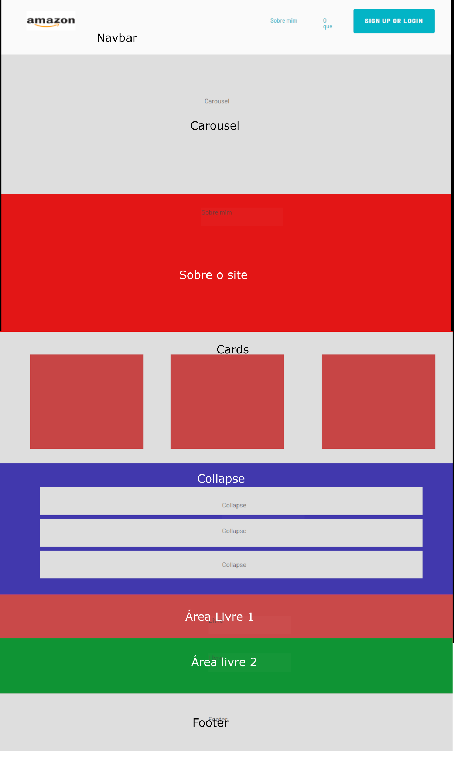

Sites para treinarmos:

Sandbox para JS

<https://codesandbox.io/dashboard/discover>

Sandbox para CSS

<https://codepen.io/vastrideside/pen/qBXqavY>

API para testes

<https://ghibliapi.herokuapp.com/films/>

Studio Ghimbli tem uma API pública para testes. Documentação: <https://ghibliapi.herokuapp.com/>

Ferramentas de Wireframe:

Bubble.io

<https://www.figma.com/>

Site de exemplo:

http://177.104.61.27/exemplo/

Código Final

<!doctype html>

<html lang="en">

<!-- Bootstrap CSS -->

<link rel="stylesheet" href="https://stackpath.bootstrapcdn.com/bootstrap/4.1.3/css/bootstrap.min.css"

integrity="sha384-MCw98/SFnGE8fJT3GXwEOngsV7Zt27NXFoaoApmYm81iuXoPkFOJwJ8ERdknLPMO" crossorigin="anonymous">

<link rel="stylesheet" href="style.css">

<link rel="stylesheet" href="fontawesome-free-6.0.0-beta3-web/css/all.css">

<link rel="stylesheet" href="css/all.css">

<head>

<title>Hello, world!</title>

</head>

<body >

<!-- Código começa aqui -->

<!-- Navbar começa aqui -->

<nav class="navbar navbar-expand-md bg-dark navbar-dark">

<!-- Brand -->

<a class="navbar-brand" href="#">

<img style="width:40px;" src="https://getbootstrap.com/docs/4.0/assets/brand/bootstrap-solid.svg" >

Lhamas S/A

</a>

<!-- Toggler/collapsibe Button -->

<button class="navbar-toggler" type="button" data-toggle="collapse" data-target="#collapsibleNavbar">

<span class="navbar-toggler-icon"></span>

</button>

<!-- Navbar links -->

<div class="collapse navbar-collapse" id="collapsibleNavbar">

<ul class="navbar-nav">

<li class="nav-item">

<a class="nav-link" href="#about">About</a>

</li>

<li class="nav-item">

<a class="nav-link" href="#">Link</a>

</li>

<li class="nav-item">

<a class="nav-link" href="#">Link</a>

</li>

</ul>

</div>

</nav>

<!-- Navbar acaba aqui -->

<!-- Carousel inicia aqui -->

<div id="demo" class="carousel slide d-none d-sm-block" data-ride="carousel" >

<!-- Indicators -->

<ul class="carousel-indicators">

<li data-target="#demo" data-slide-to="0" ></li>

<li data-target="#demo" data-slide-to="1" class="active"></li>

<li data-target="#demo" data-slide-to="2" ></li>

</ul>

<!-- The slideshow -->

<div class="carousel-inner ">

<div class="carousel-item " id="firstSlide">

<img style="width:100%;" src="img/animal36467551920-4298953354ee0d69647c215159f0bf3c-1200x600.jpg"

alt="Los Angeles">

</div>

<div class="carousel-item active">

<img style="width:100%" src="img/Lhama-em-Machuca-povoado-de-Machuca-3.jpg" alt="Chicago">

<div class="carousel-caption ">

<h3> Lhamas são legais</h3>

<p>Lorem ipsum dolor sit, amet consectetur adipisicing elit. Dignissimos ab quam est, incidunt numquam

placeat ullam dolorum ea provident voluptas illo tenetur quis voluptates amet aliquam? Placeat molestiae

perspiciatis illo.</p>

</div>

</div>

<div class="carousel-item">

<img style="width:100%" src="img/paisajes-peruanos-alpaca.jpg" alt="New York">

</div>

</div>

<!-- Left and right controls -->

<a class="carousel-control-prev" href="#demo" data-slide="prev">

<span class="carousel-control-prev-icon"></span>

</a>

<a class="carousel-control-next" href="#demo" data-slide="next">

<span class="carousel-control-next-icon"></span>

</a>

</div>

<!-- Carousel acaba aqui -->

<!-- About acaba aqui -->

<div class="container-fluid pt-5 pb-5" id="about">

<div class="row">

<div class="col-12 text-center">

<p class="display-4">Sobre Lhamas</p>

</div>

</div>

<div class="row">

<div class="col-12 text-center">

<p >Lorem ipsum dolor sit, amet consectetur adipisicing elit. Quo porro soluta facere laboriosam facilis quae ducimus repudiandae, tempora voluptates corporis ut deserunt non nesciunt nemo deleniti iste animi optio placeat?</p>

</div>

</div>

<div class="row">

<div class="col-12 text-center">

<!-- Meu modal começa aqui-->

<!-- Button to Open the Modal -->

<button type="button" class="btn btn-primary" data-toggle="modal" data-target="#myModal">

Curiosidades sobre Lhamas

</button>

<!-- The Modal -->

<div class="modal" id="myModal">

<div class="modal-dialog">

<div class="modal-content">

<!-- Modal Header -->

<div class="modal-header">

<h4 class="modal-title">Curiosidades sobre Lhamas</h4>

<button type="button" class="close" data-dismiss="modal">&times;</button>

</div>

<!-- Modal body -->

<div class="modal-body">

<p>Médicos e pesquisadores determinaram que os lhamas possuem anticorpos que seriam adequados

para o tratamento de certas doenças.[3] Cientistas vem estudando de que forma os lhamas

poderiam contribuir na luta contra os coronavírus, incluindo MERS e o SARS-CoV-2 que causa o

COVID-19.</p>

</div>

<!-- Modal footer -->

<div class="modal-footer">

<button type="button" class="btn btn-danger" data-dismiss="modal">Close</button>

</div>

</div>

</div>

</div>

<!-- MEU modal termina aqui-->

</div>

</div>

</div>

<!-- About acaba aqui -->

<!-- Cards começa aqui -->

<div class="container mb-5 pl-5 pr-5">

<div class="row">

<div class="col-4">

<div class="card" style="width:250px">

<img class="card-img-top" src="img/a9487516ee2dfcd9622dfa551527ee03--llama-llama-ecuador.jpg" alt="Card image">

<div class="card-body">

<h4 class="card-title">Uma gangue de lhamas</h4>

<p class="card-text">Veio para o lugar errado amigo</p>

</div>

</div>

</div>

<div class="col-md-4">

<div class="card" style="width:250px">

<img class="card-img-top" src="img/download (3).jfif" alt="Card image">

<div class="card-body">

<h4 class="card-title">Roberto</h4>

<p class="card-text">Lorem ipsum dolor sit amet consectetur adipisicing elit. Impedit ratione rerum numquam labore neque praesentium quia, veritatis, nam esse, maiores repellendus laboriosam aut est! Alias fuga maiores quod porro laudantium!</p>

</div>

</div>

</div>

<div class="card-md-4" style="width:250px">

<img class="card-img-top" src="img/195973_1.jpg" alt="Card image">

<div class="card-body">

<h4 class="card-title">Baby lhama</h4>

<p class="card-text">Baby lhama dododododoo</p>

</div>

</div>

<div class="col-4">

</div>

</div>

</div>

<!-- Cards acaba aqui -->

<!-- Collapse acaba aqui -->

<div class="container">

<div class="row">

<div class="col-12">

</div>

</div>

</div>

<!-- Collapse começa aqui -->

<div class="container-fluid bg-secondary text-white p-3 pl-5 pr-5">

<div class="row">

<div class="col-12 text-center display-4 mb-3">

Lhamas Famosas

</div>

</div>

<div class="row">

<div class="col-12 text-dark">

<div id="accordion">

<div class="card">

<div class="card-header">

<a class="card-link text-secondary" data-toggle="collapse" href="#collapseOne">

Frederick B. Lhama

</a>

</div>

<div id="collapseOne" class="collapse show" data-parent="#accordion">

<div class="card-body">

Lorem ipsum dolor sit amet, consectetur adipisicing elit. Distinctio amet id iste earum esse. Praesentium culpa amet deserunt dignissimos dolorem, ratione reiciendis nihil eum vero quisquam, a dolor, natus neque?

</div>

</div>

</div>

<div class="card">

<div class="card-header">

<a class="collapsed card-link" data-toggle="collapse" href="#collapseTwo">

Dhalai Lhama

</a>

</div>

<div id="collapseTwo" class="collapse" data-parent="#accordion">

<div class="card-body">

Lorem ipsum dolor sit, amet consectetur adipisicing elit. Ab mollitia, perspiciatis beatae repellat veniam sunt tempora voluptatem explicabo nostrum? Assumenda modi nemo hic cupiditate expedita deserunt laborum maiores reprehenderit rem!

</div>

</div>

</div>

<div class="card">

<div class="card-header">

<a class="collapsed card-link" data-toggle="collapse" href="#collapseThree">

Kuzco

</a>

</div>

<div id="collapseThree" class="collapse" data-parent="#accordion">

<div class="card-body">

Lorem ipsum dolor sit amet consectetur adipisicing elit. Dolorum consequatur error repellendus aliquid non ad ipsa nemo, ducimus, doloribus, molestiae nam delectus deserunt corrupti. Neque beatae fuga molestiae culpa optio.

</div>

</div>

</div>

</div>

</div>

</div>

<div class="row">

<div class="col-12">

<div class="container">

<h2>Lhamas cuspidoras</h2>

<a href="#demo" class="btn btn-primary" data-toggle="collapse">Simple collapsible</a>

<div id="demo" class="collapse">

Lorem ipsum dolor sit amet, consectetur adipisicing elit,

sed do eiusmod tempor incididunt ut labore et dolore magna aliqua. Ut enim ad minim veniam,

quis nostrud exercitation ullamco laboris nisi ut aliquip ex ea commodo consequat.

</div>

</div>

</div>

</div>

</div>

<!-- Collapse começa aqui -->

<!-- Customizado1 começa aqui -->

<!-- Customizado1 termina aqui -->

<!-- Customizado2 começa aqui -->

<!-- Customizado2 termina aqui -->

<!-- Footer começa aqui -->

<footer class="bg-dark text-light text-center p-3">

<div class="container-fluid">

<div class="row">

<div class="col-6 text-left">

Links mais acessados

<div class="list-group bg-dark list-group-flush">

<a href="#" class="list-group-item list-group-item-action bg-dark text-light">Home</a>

<a href="#" class="list-group-item list-group-item-action bg-dark text-light">Loja Online</a>

<a href="#" class="list-group-item list-group-item-action bg-dark text-light">Blog</a>

</div>

</div>

<div class="col-6 text-left">

Redes Sociais

<div class="list-group bg-dark list-group-flush">

<a href="#" class="list-group-item list-group-item-action bg-dark text-light"><i class='fab fa-facebook'></i> Facebook</a>

<a href="#" class="list-group-item list-group-item-action bg-dark text-light"><i class="fa-brands fa-linkedin"></i> Linkedin</a>

<a href="#" class="list-group-item list-group-item-action bg-dark text-light"><i class="fa-brands fa-twitter"></i> Twitter</a>

</div>

</div>

</div>

<div class="row mt-3">

<div class="col-12 text-center">

Dener Ottolini@2021

</div>

</div>

</div>

</footer>

<!-- Footer termina aqui -->

<!-- Código Termina aqui -->

<!-- Optional JavaScript -->

<!-- jQuery first, then Popper.js, then Bootstrap JS -->

<script src="https://code.jquery.com/jquery-3.3.1.slim.min.js"

integrity="sha384-q8i/X+965DzO0rT7abK41JStQIAqVgRVzpbzo5smXKp4YfRvH+8abtTE1Pi6jizo"

crossorigin="anonymous"></script>

<script src="https://cdnjs.cloudflare.com/ajax/libs/popper.js/1.14.3/umd/popper.min.js"

integrity="sha384-ZMP7rVo3mIykV+2+9J3UJ46jBk0WLaUAdn689aCwoqbBJiSnjAK/l8WvCWPIPm49"

crossorigin="anonymous"></script>

<script src="https://stackpath.bootstrapcdn.com/bootstrap/4.1.3/js/bootstrap.min.js"

integrity="sha384-ChfqqxuZUCnJSK3+MXmPNIyE6ZbWh2IMqE241rYiqJxyMiZ6OW/JmZQ5stwEULTy"

crossorigin="anonymous"></script>

<!-- Required meta tags -->

<meta charset="utf-8">

<meta name="viewport" content="width=device-width, initial-scale=1, shrink-to-fit=no">

</body>

</html>